Press release
31 january 2025

PHILIPPE COGNÉE
FRAGMENTED LANDSCAPES
8 March - 10 May 2025

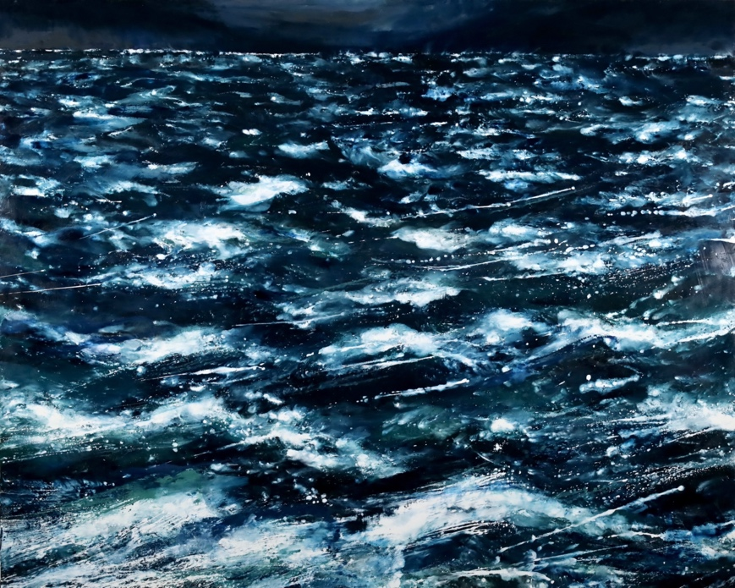
Stormy sea n°2, 2024, wax painting on canvas, 51 × 63 in.

Following on from acclaimed exhibitions of his work at Paris' Musée Bourdelle and Musée de l'Orangerie in 2023, Philippe Cognée is presenting his latest interpretation of landscapes at Galerie Templon. Forests, fields and sea views convey the power of his practice, his unconditional love for the medium of painting and his caustic view of our disenchanted era.

Philippe Cognée has spent the last twenty or so years tackling subjects associated with the banality of our civilisation, such as supermarkets, motorways and other impersonal architectures, and beautifying them with his unique painting technique, using wax that is heated and crushed to produce a blurred effect. His canvases are often produced in series, drawing on our technological culture – from photography to video and digital – to question the relevance of figurative painting today. They propose a deconstruction of the contemporary gaze as part of an existential questioning of the thinning away of the image.

With Fragmented Landscapes, Cognée has swapped the gleaming hues of his 2022 Insomniac Landscapes for a more restrained palette coupled with a bold hanging approach. The canvases are installed on a giant frieze, unfurling to display an unexpected panorama reminiscent of the seascapes painted by Matthieu van Plattenberg or Vincent Van Gogh. As ever, Philippe Cognée’s highly skilled use of his encaustic technique creates an impression of subjects engulfed in wax, almost unrecognisable, blurred to the point of abstraction. The scenes he creates are fascinating and disturbing in equal measure. The dripping, scratched, diluted or liquified surfaces present the viewer with a dilemma: whether to contemplate nature in all her endangered majesty, or to act. Each landscape bears witness to an irreconcilable misunderstanding between nature and humanity, celebrating the beauty of a world haunted by the climate anxiety that consumes our societies.

Born in 1957, Philippe Cognée works in Nantes and Paris. A Villa Medici laureate in 1990 and Prix Marcel Duchamp finalist in 2004, Philippe Cognée spent many years teaching at the Paris Ecole Nationale Supérieure des Beaux Arts, where he trained a new generation of young figurative painters. They joined him for his recent participation in the Musée d’Orsay Painters’ Day exhibition in Paris (September 2024).
His work has been the subject of numerous solo exhibitions, including at Geneva's MAMCO - Museum of Modern and Contemporary Art (2006), the Haute-Normandie regional contemporary art collection (2007), Musée de Grenoble (2013), Château de Chambord (2014), Fondation Fernet-Branca de Saint Louis (2016), Domaine de Chaumont sur Loire (2020), Thonon-les-Bains-Chapelle de la Visitation (2022), Musée de Grenoble (2022), Musée de Tessé, Musée des Beaux-Arts du Mans (2022), and Musée Bourdelle (2023) and Musée de l’Orangerie (2023), both in Paris. He is preparing a vast monographic exhibition for summer 2025, to be held at Musée Paul Valéry in Sète.
His art also features in a great many museum collections, such as at the Musée National d’Art Moderne - Centre Pompidou, Fondation Cartier and Collection Louis Vuitton in Paris as well as the Museum Ludwig in Cologne, Museum Voorlinden in the Netherlands, Musée Cantonal des Beaux-Arts in Lausanne and Musée de la Chasse et de la Nature in Paris, which recently commissioned two large-scale landscapes. Philippe Cognée has been represented by Galerie Templon since 2002.

